RESULTS OF DIGITAL DUN LAOGHAIRE SURVEY #1 of Dun Laoghaire’s Tech Cluster
September 2016

Document prepared by Eoin Costello, Project Leader Digital Dun Laoghaire
Background
The goal of this survey is to help support the creation of a strong cluster of digital companies in our town for the jobs and innovation this will bring to Dun Laoghaire. To do this we need to better understand the current status of digital companies in the town and how we can work with DL BID and other stakeholders such as DLR Local Enterprise Office, DLR Chamber of Commerce and others to help digital businesses thrive in Dun Laoghaire. By digital we mean technology in its broadest sense, from digital creative studios to analytics to enterprise/SaaS software.
This is the first survey of digital companies to be carried out in Dun Laoghaire by the new Digital Dun Laoghaire project in partnership with the Dun Laoghaire Business Improvement District and Sigmar Recruitment. Digital Dun Laoghaire is an initiative of Dun Laoghaire BID.
Digital Dun Laoghaire has to date identified 65+ digital companies located in Dun Laoghaire. The survey closed on September 26th 2016 and received 25 responses.
Summary of Findings
- Sectors - The results show that there is a strong base of digital companies in the town (in particular creative digital agencies and enterprise software companies) with a specialisation in the areas that have the potential to feed into the value chain of Silicon Docks and Sandyford.
- Why Dun Laoghaire - The most important factors influencing respondents in their choice of Dun Laoghaire was lifestyle (64%), public transport (44%), suitable office space (40%) and proximity to key customers (24%). This should be reflecting in future communications plans for Dun Laoghaire as a digital cluster.
- Will companies engage in development of a cluster - The respondents recognise that being in a cluster is good for their business (64%) making it easier to recruit talent (48%) and gain new customers (44%). Respondents displayed an appetite for deeper engagement. Current engagement levels between digital companies in the town are relatively low (7 respondents indicated that they are only aware of 2 other digital companies in the town). This provides a good opportunity to build from currently low collaboration levels (8 respondents indicated that they only do business with 1 other digital company in Dun Laoghaire) and achieve positive results over the coming years.
- Is the sector growing? - The majority of respondents are growth orientated (96%). It is clear that strengthening the digital cluster in Dun Laoghaire will result in more jobs. Respondents plan to create 450 new jobs in the town over the next two years. 4.35% of the companies surveyed indicated that they intended to create between 20 and 50 new jobs over the 24 month period to 2018, with 27% indicating they would be creating between 6 and 10 new jobs.
- Threats to Growth of Companies - The biggest challenges to this growth are access to new customers (48%), access to talent (48%), access to scaling supports (44%), access to suitable office space (24%) and to funding (24%).
- Threats to Growth of a Cluster - The key threats to the development of a growth in the cluster of digital companies through companies potentially leaving Dun Laoghaire in the future are lack of suitable office space (8 respondents), rent increases (5 respondents) and lack of talent to support the growth of digital companies (4 respondents).
- Digital Dun Laoghaire - In terms of the Digital Dun Laoghaire initiative there is a very high level of awareness of it already (76%). The majority (92%) feel that the initiative could be helpful to the growth of their business.
- How can the Council help? - The respondents have a range of suggestions to Dun Laoghaire Rathdown County Council on how they might support the growth of more digital in Dun Laoghaire, these have been grouped in Section 1 below under the headings Community , Specialist Space, Talent, development of Dun Laoghaire as a hub, development of the Digital Dun Laoghaire cluster, space, rates and parking.
- Final Thoughts - Respondents had a range of questions and comments in respect of the Digital Dun Laoghaire initiative that are grouped under Section 2 below.
ANALYSIS OF RESPONSES
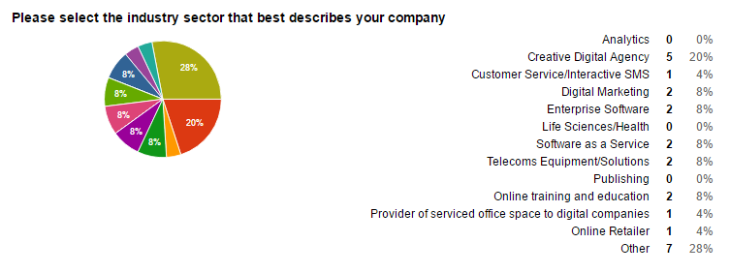
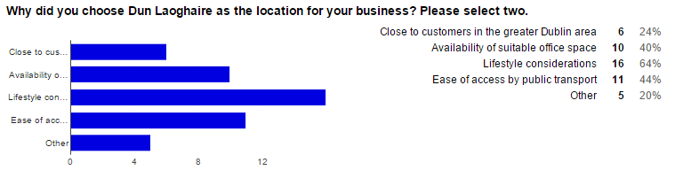

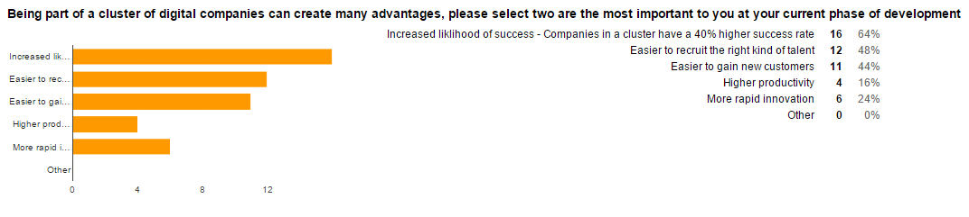
The largest number of respondents selected the fact that being in a cluster increases their company’s chances of success. It suggests that the respondents recognise the value of cooperation and are prepared to collaborate with each other in the cluster. This is an encouraging result for the potential of the cluster to develop.

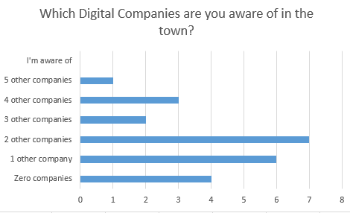
The largest number of respondents selected ‘2 other companies’, this indicates there is potential to strengthen the awareness of the 65+ digital companies that Digital Dun Laoghaire have identified as being located in the town.

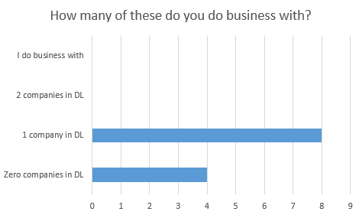
The largest number of respondents selected ‘1 other companies’, this indicates there is potential to strengthen the business collaboration between the 65+ digital companies that Digital Dun Laoghaire have identified as being located in the town.

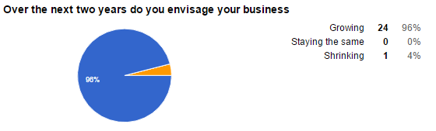
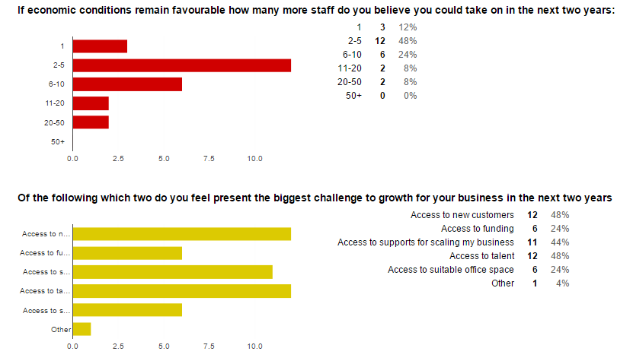

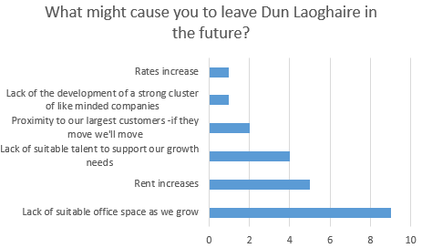

About Digital Dun Laoghaire
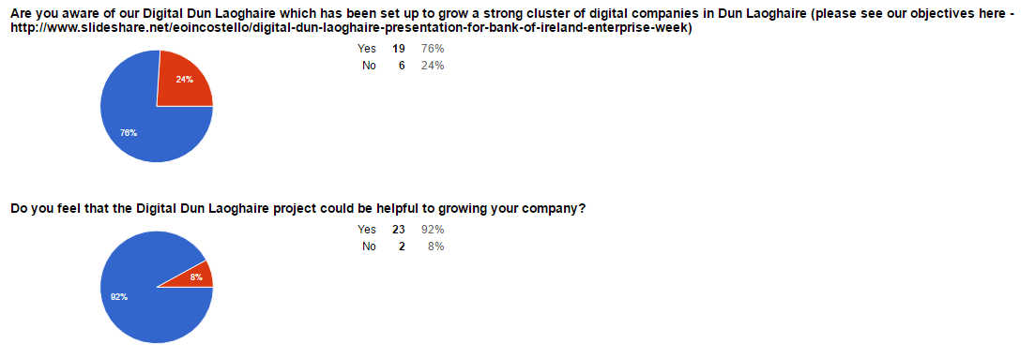

SECTION 1
In your opinion what policies or measures could Dun Laoghaire Rathdown Council take to support the growth of more digital companies in the town?
The suggestions have been grouped into themes.
Community –
- Create events around a Digital Cluster idea; enable companies to meet & network; organise educational events to learn from each other.
- Provide matchmaking/partnerships for digital companies with established businesses in the area.
- More co-working spaces, trade events, mentorship, connect small companies to established local businesses.
- Running information seminars using local Digital Companies especially on funding for Digital Companies (currently hard to find).
- More information about possible financial and funding support networks.

Specialist Space –
- Create a digital hub workspace.
- Dubai have a digital hub that gets like minded people together, we need the same in Dun Laoghaire. Need a focal point so than an area can point and say "Look what we've done" and this disarms the cynics.
- Funding for a digital Hub.
- Launch an incubator/co-working space using wasted retail land. Especially near the mainstreet.
- Set up a Digital Hub similar to the one in the City Centre.
- Promote a digital hub where companies can meet, collaborate, learn about funding or opportunities etc. - Increase in office space or hot desk space for smaller digital companies who are not yet ready to commit to long term leases.
- Create incubation spaces and resources for startup businesses and mentoring to help them.

Talent –
- Help recruitment of tech staff which is currently a major issue for us.

Development of Dun Laoghaire as a hub –
- Help brand Dun Laoghaire better, clean the streets more, get Dublin city bikes here, sort our empty shop fronts, facilitate weekday food markets, more festivals and possibly business/digital summits.
- They should be involved in assisting the provision of infrastructure, packaging DL as a destination for Startups. - Retain grants such as the Trading Online voucher and implement other digital design relevant vouchers e.g. A voucher for branding etc.
- Advertise the lifestyle benefit of living in the area 'From the Mountains to the Sea’.

Development of the Digital Dun Laoghaire Cluster –
- Harness the good will and talents of those that are already here.
- Partner with (proven track record) experienced ecosystem builders.
- Online directory showing digital businesses in the area.
- Initiatives eg. Our own Culture Night, digital installations in the town with a focus on innovation and/or design. - Promote a better understanding of digital marketing.

Space –
- Approve the planning applications for more mixed use office and residential developments to meet demand for suitable office space plus affordable accommodation for staff.

Rates & Parking - Bring down the rates and provide parking options.

SECTION 2

Last question, is there anything you would like to add?

1. Does Digital Cluster idea include Digital Media content providers? e.g. podcasters? video makers? online writers and bloggers? I don't see a category for them above. There are a lot of independent production companies and media freelancers based in the area - down to Dalkey and up to Blackrock; including them would bring a lot of creativity to the group, so I think it's very important to be clear who is eligible to be involved in this.

2. Great initiative. - Best of luck, great idea. - Great Initiative and happy to support it. - I would be willing to get involved in this. Please contact me. - We think this is a fantastic initiative and having lived, worked in and done business for years in Dun Laoghaire we would be very excited to be involved in the pioneering of a Digital Hub or Cluster in the area. - I think it is a great initiative and we will be delighted to be an active participant.

3. Our company may not be the only company that trades in Dun Laoghaire but has its registered office in Dublin city centre. Compiling a complete database of digital companies that are already in Dun Laoghaire would be good.

4. There is a huge opportunity in getting Dun Laoghaire's established businesses active in the digital economy, especially digital marketing and e-commerce.

5. We're looking forward to being part of DL Bid, helping to grow the digital community and benefit commercial where it make sense.

6. National/International awareness around this initiative may be key to success.

